**Computing in Epidemiology and biostatistics Homework 1**

**Euchie Jn Pierre (R10H44002)**

**Number 1**

1-pf(3.2, 3, 194)

[1] 0.02448583 *# P-value of F score*

x<-seq(0,10, by = 0.1)

length (x)

[1] 101

ypdf<-df(x, df1 = 3, df2 = 194)

plot (x, ypdf,type = 'l')

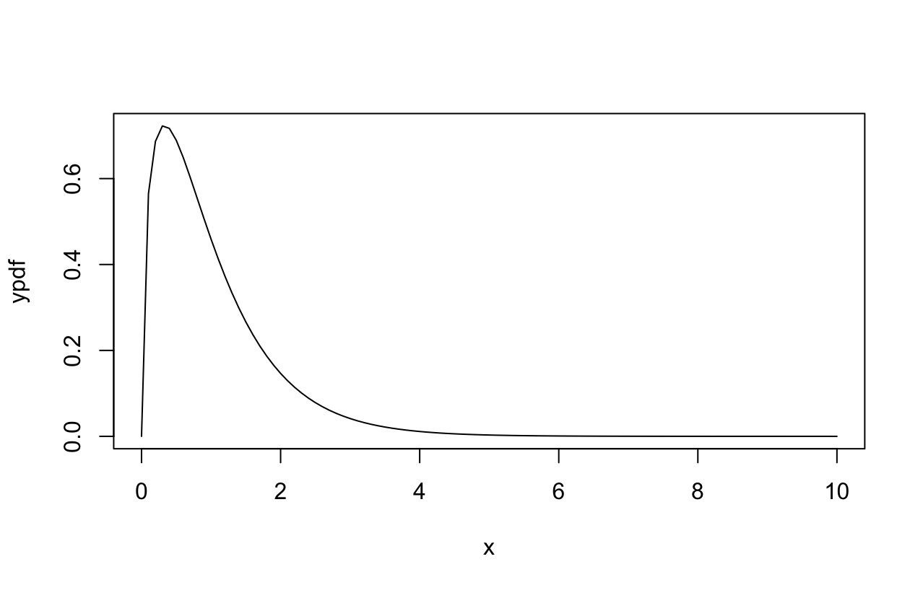

Diagram showing the probability density function of the F distribution.

ycdf<-pf(x, df1 = 3, df2 = 194)

plot(x, ycdf, type = 'l')

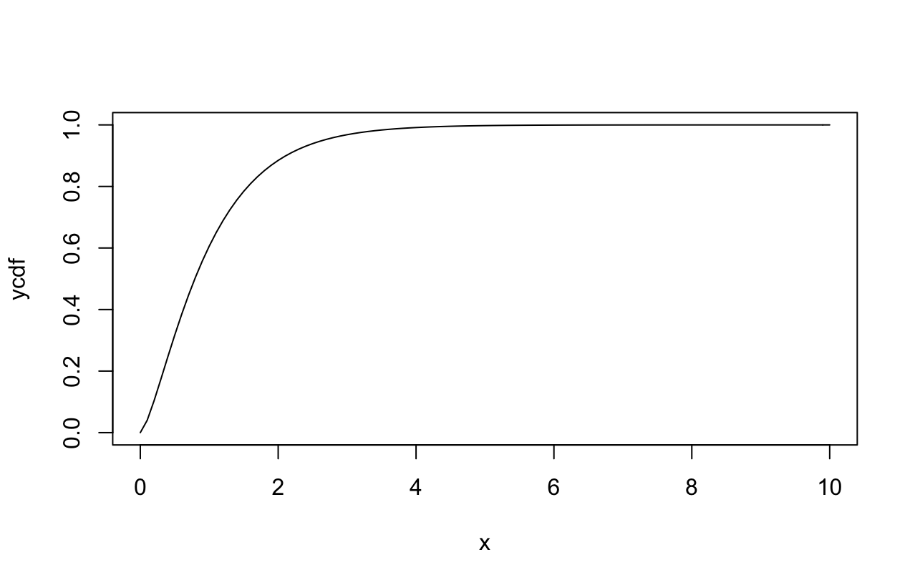

Diagram showing the cumulative distribution function of the F distribution

**Number 2**

**2*pt(q=-2.08, df=136)**

**[1] 0.03940267*# p-value of t distribution with t score of -2.08***

**2*pt(q=2.45, df=136, lower.tail=FALSE)**

**[1] 0.01555642 *# p-value of t distribution with t score of 2.45***

**x<-seq(0,10, by = 0.1)**

**curve(dt(x, df=136), from=-3, to=3)**

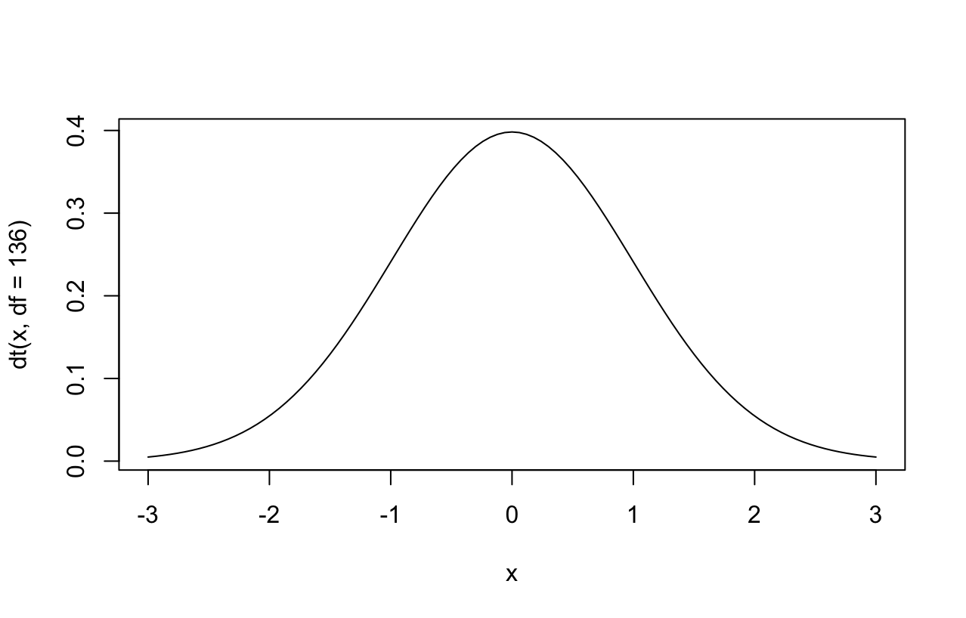

Diagram showing the probability density function of the t distribution.

**curve(pt(x, df=136), from=-3, to=3)**

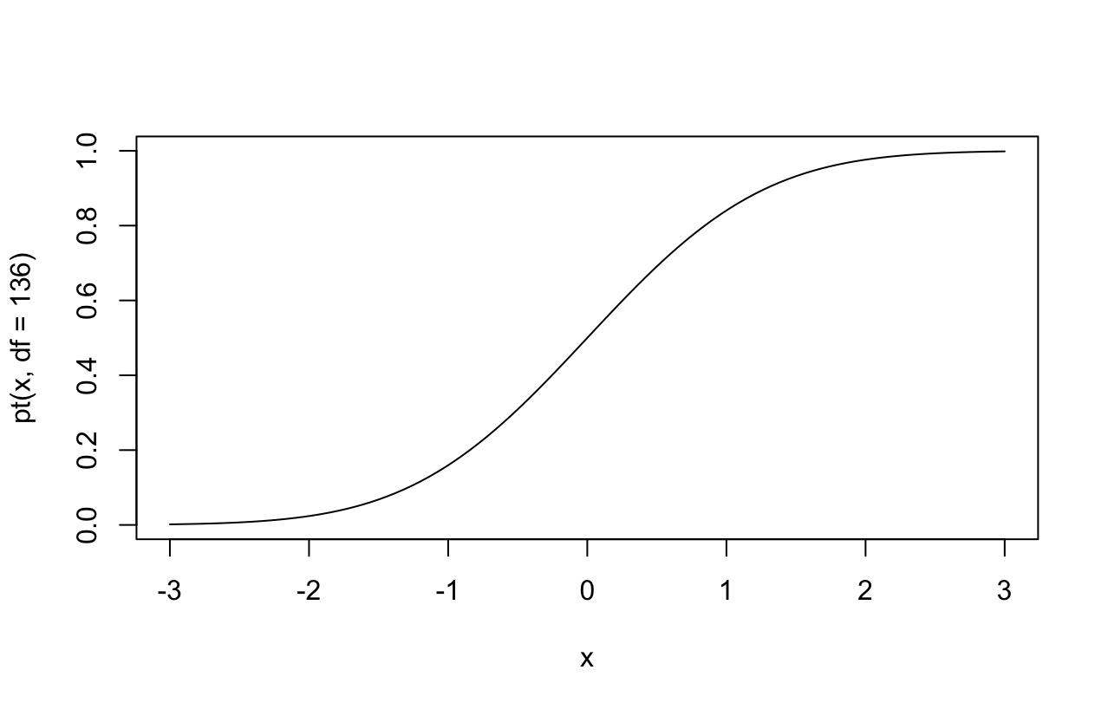

Diagram showing the cumulative distribution function of the t distribution.